**Test Case 0039 (part 1)**

**System:** VirtuCardsClient & VirtuCardsHost

**Description:** test that verifies that the profanity chat is working properly

**Severity:** 3

**Instructions**

1. Start VirtuCardClient application
2. Click the button labeled “Sign In”
3. Enter “virtucards01@gmail.com” into the text input labeled “Enter email…”
4. Enter “Testing1” into the text input labeled “Enter password…”
5. Press the button labeled “Login”
6. A window should appear saying “Login Success”
7. Press the OK button that appears on that window
8. Start VirtuCardHost application
9. Repeat steps 2-7 but on the VirtuCardHost application
10. The checkbox “Allow Host to Join” should be checked on the host
11. Press the Create Game button
12. In the VirtuCardClient application enter the 6-character room code found on the host’s screen into the field labeled “Enter Code…”
13. Press the Join Game button on the client
14. After the name TestCase0001 appears in the player list on the host side, press the Start Game button
15. On the client-side, write any swear word in the chat and press send

**Expected Result:** Since you have sent one swear word in the chat, you get the first warning from the host, and the message will not be sent to the host nor other players in the game

**Test Case 0039 (part 2)**

**System:** VirtuCardsClient & VirtuCardsHost

**Description:** test that verifies that the profanity chat is working properly

**Severity:** 3

**Instructions**

1. Start VirtuCardClient application
2. Click the button labeled “Sign In”
3. Enter “virtucards01@gmail.com” into the text input labeled “Enter email…”
4. Enter “Testing1” into the text input labeled “Enter password…”
5. Press the button labeled “Login”
6. A window should appear saying “Login Success”
7. Press the OK button that appears on that window
8. Start VirtuCardHost application
9. Repeat steps 2-7 but on the VirtuCardHost application
10. The checkbox “Allow Host to Join” should be checked on the host
11. Press the Create Game button
12. In the VirtuCardClient application enter the 6-character room code found on the host’s screen into the field labeled “Enter Code…”
13. Press the Join Game button on the client
14. After the name TestCase0001 appears in the player list on the host side, press the Start Game button
15. On the client-side, write any swear word in the chat and press send
16. Repeat the previous step two more times

**Expected Result:** The player will get a warning message for the first two times that the player has sent the chat, but when the player ignores the warning and sends another swear word, the player is banned from chat until the next game. None of the messages will be sent to the chat. When the player tries to send something else in the chat, the player will be notified that the user is banned from the chat.

**Test Case 0039 (part 3)**

**System:** VirtuCardsClient & VirtuCardsHost

**Description:** test that verifies that the profanity chat is working properly

**Severity:** 3

**Instructions**

1. Start VirtuCardClient application
2. Click the button labeled “Sign In”
3. Enter “virtucards01@gmail.com” into the text input labeled “Enter email…”
4. Enter “Testing1” into the text input labeled “Enter password…”
5. Press the button labeled “Login”
6. A window should appear saying “Login Success”
7. Press the OK button that appears on that window
8. Start VirtuCardHost application
9. Repeat steps 2-7 but on the VirtuCardHost application
10. The checkbox “Allow Host to Join” should be checked on the host
11. Press the Create Game button
12. In the VirtuCardClient application enter the 6-character room code found on the host’s screen into the field labeled “Enter Code…”
13. Press the Join Game button on the client
14. After the name TestCase0001 appears in the player list on the host side, press the Start Game button
15. On the client-side, write any swear word in the chat and press send
16. Repeat the previous step two more times
17. Click the default message that is given for the chat.

**Expected Result:** The user will not be able to even send innocent messages because the player has lost the privilege to speak to the chat for bad behavior.

**Test Case 0039 (part 4)**

**System:** VirtuCardsClient & VirtuCardsHost

**Description:** test that verifies that the profanity chat is working properly

**Severity:** 3

**Instructions**

1. Start VirtuCardClient application
2. Click the button labeled “Sign In”
3. Enter “virtucards01@gmail.com” into the text input labeled “Enter email…”
4. Enter “Testing1” into the text input labeled “Enter password…”
5. Press the button labeled “Login”
6. A window should appear saying “Login Success”
7. Press the OK button that appears on that window
8. Start VirtuCardHost application
9. Repeat steps 2-7 but on the VirtuCardHost application
10. The checkbox “Allow Host to Join” should be checked on the host
11. Press the Create Game button
12. Press settings
13. Uncheck the “filter chat”
14. In the VirtuCardClient application enter the 6-character room code found on the host’s screen into the field labeled “Enter Code…”
15. Press the Join Game button on the client
16. After the name TestCase0001 appears in the player list on the host side, press the Start Game button
17. On the client-side, write any swear word in the chat and press send

**Expected Result:** unlike normal games, when the host does want the chat filtered, players can say whatever they want in the chat without any consequences.

Part 1

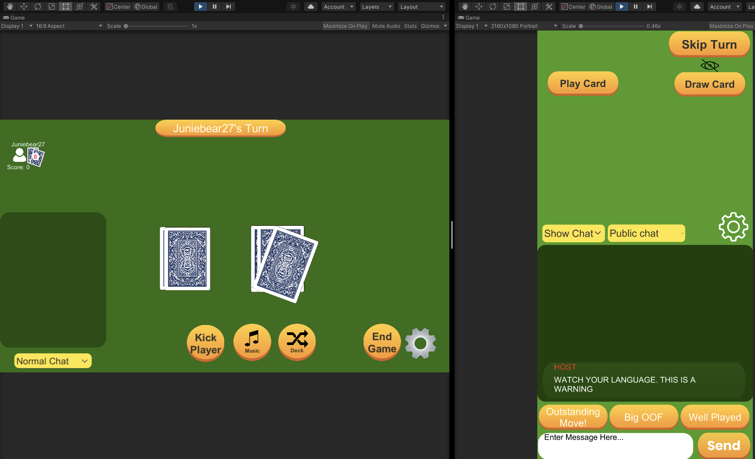

The client has said a bad word, so the client receives a message from the host saying it is a bad word and doesn’t send the message to everybody.

Part 2

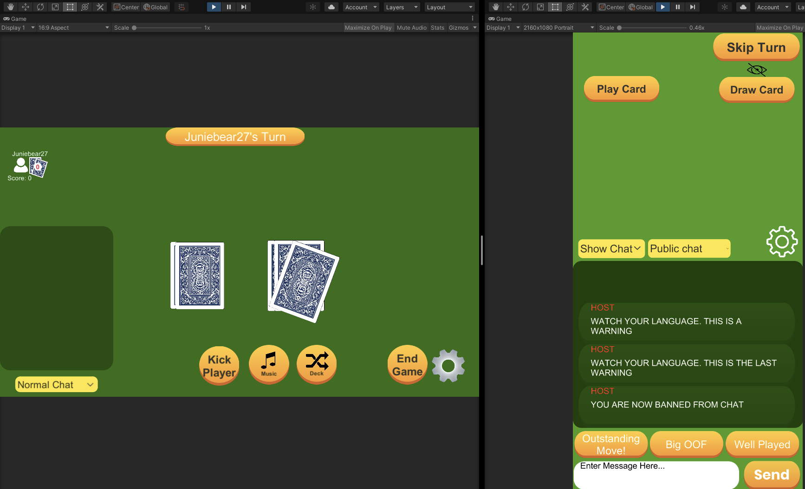

The client has said too many bad words that they got 2 warnings and is notified that the user is banned from saying anything in the chat

Part 2 & part 3

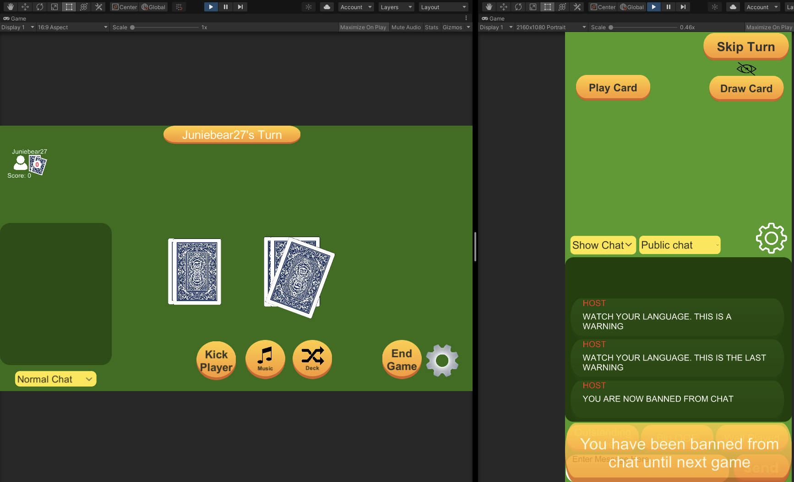

After the user has been banned from the chat, when they try to say something in the chat or press the innocent default messages, they are shown a quick message that reminds them that they are banned from chat.

Part 4

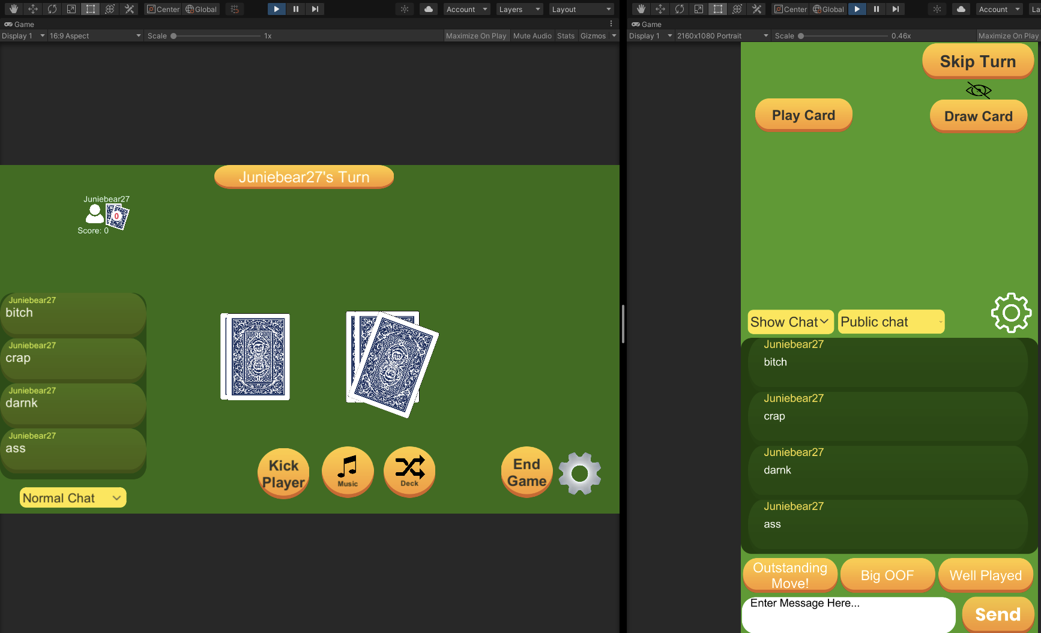

When the host disables the filter in the chat before the game starts, the player can say whatever they want without getting in trouble.